BAOMS Travel Grant Report 2021-2023

Jennifer Hon MBChB, BDS, MA, MPH

Purpose: Maintenance costs while undertaking an unpaid fellowship at the Program for Global Surgery & Social Change, Harvard Medical School
Location: Boston, USA; Cape Town and Eastern Cape, South Africa; Geneva, Switzerland
Duration: 2 years

Global Surgery

In 2015, I was fortunate to attend the launch of the Lancet Commission for Global Surgery at the Royal Society of Medicine. This seminal paper set out the stark reality of (then) 5 billion people lacking access to safe and affordable surgery, and made a strong argument that surgical system strengthening would reap a substantial return on investment for countries’ economic growth. In the same year, the World Health Assembly in Geneva passed a resolution (WHA68.15) that strengthening essential and emergency surgery and anaesthesia was a component of universal health coverage (UHC). These events gave rise to the Global Surgery movement, with surgery finally gaining a place on the Global Health agenda.

I had found real inspiration and purpose that year: I had trained in medicine to make a positive impact, but the needs of the most vulnerable in the world were still overlooked. As OMFS surgeons, our awareness tends to be limited to the ‘parachute- mission’ model of managing cleft and Noma, but the problem is far greater, and the solution should be more sustainable. It is an injustice that people in poor countries face death and disability because of lack of access to safe caesarean section, appendicectomy or management of fractures – to name some surgical basic procedures. It took another five years for my personal situation to allow me the opportunity to take time out of clinical training and dedicate time to being part of this movement, but I am so thankful that I have.

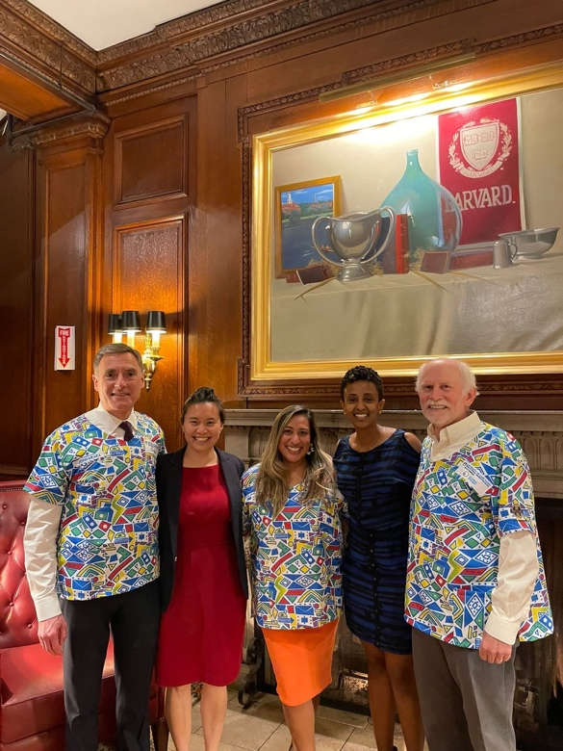
Program for Global Surgery & Social Change (PGSSC)

The PGSSC at Harvard Medical School had done much of the work that formed the Lancet Commission for Global Surgery, and had been turning its efforts to advocating to low- and middle-income country (LMIC) governments to formulate and implement national surgical policy. Various faculty members run ‘labs’ that concentrate on certain themes or geographic areas, and rely on a relatively small cohort of unpaid fellows (usually surgical residents taking two years out for research) and research collaborators (usually medical students) to undertake projects. Faculty are mostly but not exclusively surgeons or anaesthetists themselves; there is also a smattering of career-academics. Of the surgeons, a wide variety of specialisms is represented, but importantly, the mission of PGSSC is not to advocate for the expansion of a particular subspecialty but rather advocate for the development of the entire surgical ecosystem. From the outset, I knew that there would be very little overlap with my OMFS background. In addition, the OMFS community (particularly in the UK) has not been well-represented in the Global Surgery movement thus far, so it was a privilege to fly the flag for us at Harvard.
Celebrating the end of a successful PGSSC year (2021-22) with John Meara, Rashi Jhunjhunwala, Belain Eyob and Scott Corlew, with scrub tops gifted from our South African partners

Being part of the PGSSC had been a pipedream, and only became possible as a silver lining of the Covid pandemic. In 2020, I had been awarded a Knox scholarship to undertake a Masters in Public Health (MPH) in Global Health at Harvard, but this was delayed for a year, which gave me the necessary time to apply for a PGSSC fellowship (July 2021 to June 2023). These two concurrent academic activities aligned extremely well, but made for a busy couple of years!

Fellowship Activities

The in-person MPH at the Harvard School of Public Health required being in Boston from August 2021 to December 2022. However, post-pandemic policies at Harvard Medical School were slower to adapt, and PGSSC activities started remotely for the Fall semester. I chose to join the lab supervised by Dr Scott Corlew, which focused on strengthening surgical capacity in the Southern African Development Community (SADC), a region of 16 member states. One of appealing aspects of this was their focus on national surgical planning. The surgical, anaesthetic and obstetric (SAO) care technical experts’ working group for the region is chaired by Prof Emmanual Makasa who holds a monthly forum to report on news from countries in their efforts to advocate for strengthening surgical systems through policy. To this end, with Prof Makasa’s lead, I was involved in meetings with the Namibian Ministry of Health’s technical experts as we worked on an early draft of their National Surgical Obstetric and Anaesthesia Policy; I was part of a team that refined an evaluation tool for Zambia’s first surgical policy and provides baseline data for a second iteration policy; and I helped collate and analyse facility-level data for the Democratic Republic of Congo for 90 of its 400 or so facilities that offer surgery (where the vast majority of procedures are performed by non-specialists including non-physician clinicians). Further to that, our PGGSC lab team had recognised that the uptake of national surgical planning has been slow within SADC (in spite of the pandemic), which has led to research that I co-led which analyses 149 various stakeholder survey responses from the region, on the barriers and facilitators to national surgical planning. This is soon to be submitted to a suitable journal for publication.
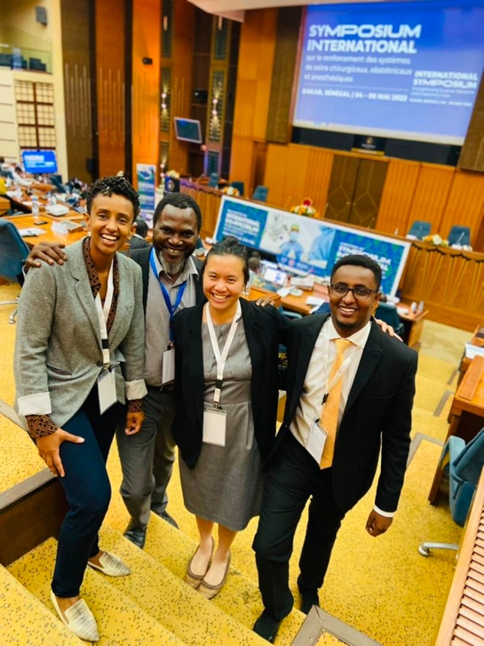
One of the highlights of the 2021-22 academic year was being invited to Dakar, Senegal for the International Symposium on Surgical, Obstetric and Anaesthesia Systems Strengthening by 2030 in Africa, co-hosted by the Senegalese Ministry of Health and Mercy Ships. I participated as a moderator for one of the technical experts’ sessions, where several countries presented their situational analysis data on surgery. Delegations from over 30 African nations including 10 Ministers of Health were in attendance.

Since finishing MPH classes in Boston, I have taken advantage of having much more geographic freedom to explore different aspects of Global Surgery with PGSSC. In February and March 2023, I spent two months with the University of Cape Town’s (UCT) Global Surgery department. The first purpose was to be a faculty member of their second Executive Leadership Course in Global Surgery, designed to train leaders to improve access and quality of surgical services in their local environments. During the week-long in-person component, I delivered a lecture on National Surgical Obstetric and Anaesthetic Planning, and have since been providing feedback to course delegates on their individual quality improvement projects. The second reason that took me to South Africa was to conduct several interviews with healthcare staff and administrators for a qualitative research project that examines the barriers and facilitators of building surgical capacity in a rural district hospital in the Eastern Cape province. Through a collaboration with Global Surgery in Action (GSiA) arm of the UCT Global Surgery department, I have been involved in the evolution of this project from ethical approval application through to data collection and now qualitative data analysis (through coding) and write-up, for which I will be first author. The project focuses on healthcare worker perspectives of a rural district hospital that has managed to expand surgical services from doing almost exclusively caesarean sections, to managing ruptured ectopics, managing burns with skin grafts, performing tendon repairs and undertaking hydrocelectomies. Through regional anaesthetic workshop training, doctors have been given enough confidence to administer general anaesthetics themselves and they are looking to expand their scope of surgical care, especially in the context of dysfunctional referral pathways to tertiary centres.
With Belain Eyob, Prof Emmanuel Makasa and Hassan Ali Daoud at the International Symposium, Senegal

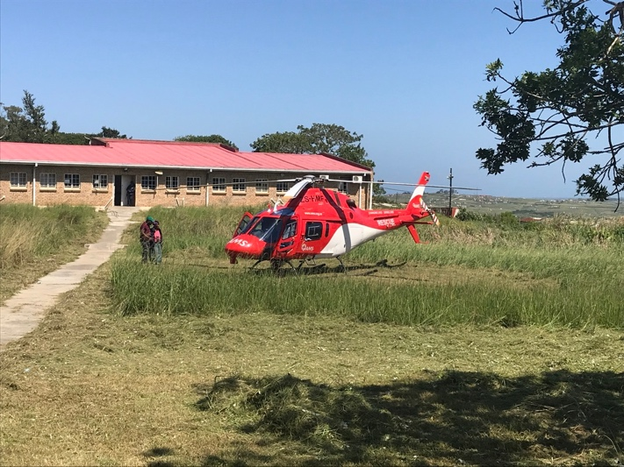
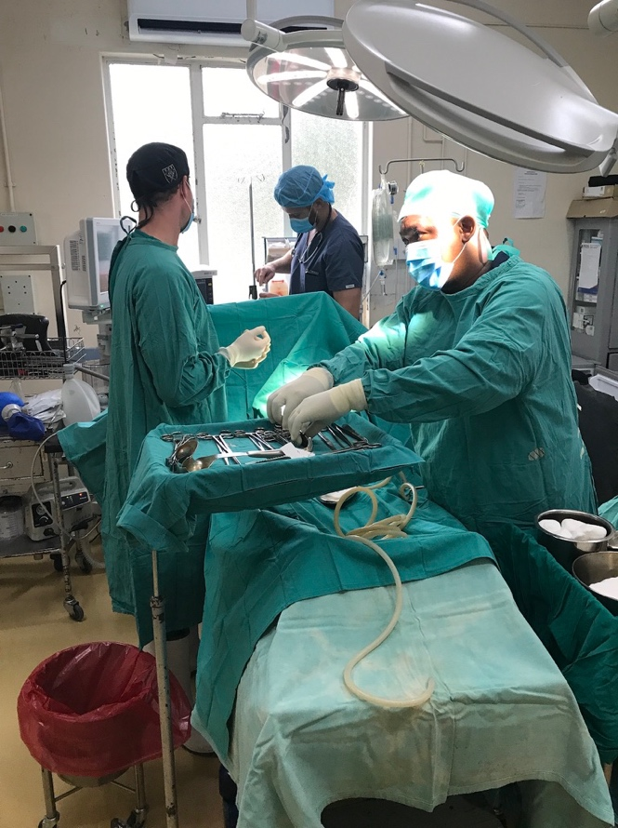
Left: There is one theatre at Madwaleni Hospital, and it is mainly used for caesarean sections under spinal anaesthetic, as I observed here. However, there is capability to deliver general anaesthetic and perform other surgeries such as skin grafts and tendon repairs. Minor procedures under local anaesthetic are performed in another space.

Below: I observed the second air transfer they had successfully organised since Covid, as the province had only recently renewed its aeromedical transfer contract. This helicopter transferred a 4yr old with acute hepatitis to the nearest tertiary unit (1.5hrs by road but 15mins by air).

As a contrasting experience to end my 2-year PGSSC fellowship during April – June 2023, I successfully applied for an elective experience at the Global Surgery Foundation (GSF). This is a relatively new non-governmental organisation based in Geneva, which seeks to convene the different sectors involved in Global Surgery and establish a multilateral fund (akin to the Global Fund) to mobilise, pool and channel financial resources to frontline organisations in LMICs that can strengthen surgical systems. My elective was fortuitously timed to coincide with the World Health Assembly (WHA) at the end of May, where the Global Surgery community convened in Geneva to witness the passing of the Emergency, Critical and Operative (ECO) care resolution, which builds on previous commitments to surgery. The week was also packed with side events, and my first five weeks at GSF was spent supporting the behind-the-scenes logistics of their high-level event, which had panellists including Atul Gawande and saw 300 in-person attendees, as well as over 300 online attendees. My remaining time at GSF has been spent refining and formalizing the processes of the SURGfund, and meeting the demands of both donors and the implementing partners receiving investment. Spending time in Geneva in a space far from both academia and clinical medicine has been eye-opening, and I have certainly had to be highly adaptable. It has also afforded me the opportunity to network with a huge diversity of people, and given me a much broader picture of the Global Surgery landscape and complexities of Global Health in general.
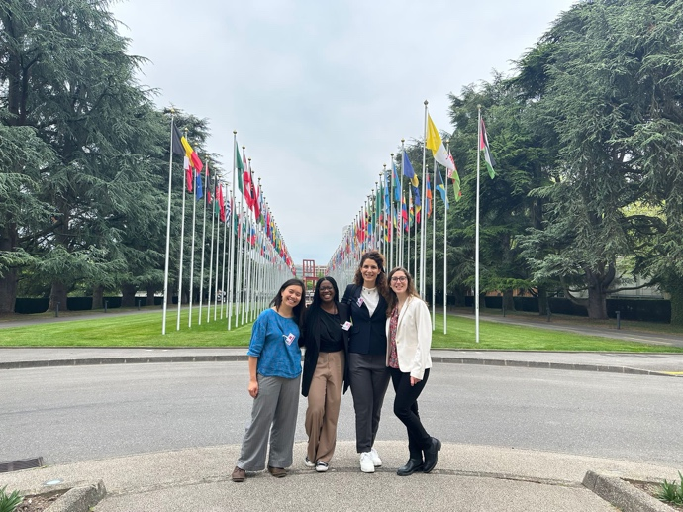
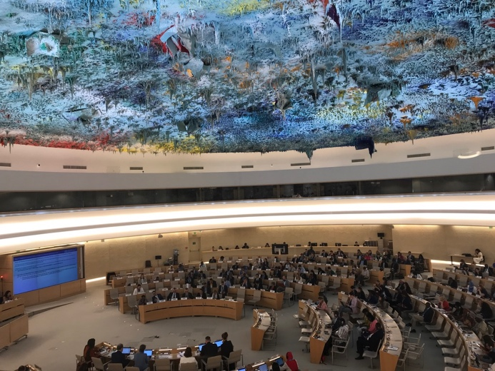
Top left: With GSF colleagues Nefti Bempong, Francesca Vittuci and Léa Simon at the United Nations’ Palais des Nations during World Health Assembly week, May 2023

Top right: Observing the World Health Assembly (WHA76) summit in action from the observers’’ gallery

Bottom left: Interviewing Prof Emmanuel Makasa as part of the GSF side event
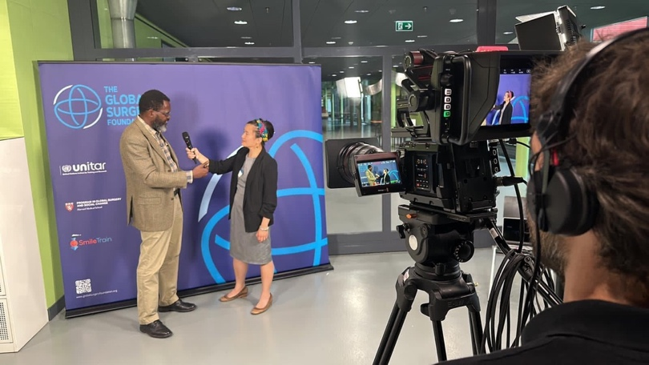
Concluding remarks

I appreciate that providing a travel grant for something that is not obviously clinical, let alone not directly OMFS-related might be deemed left-field, and I am hugely grateful to the BAOMS Endowments Committee for supporting this endeavour. To be a good surgeon is not just to have technical ability, and to be a good doctor is not necessarily just about treating the patient in front of you. It becomes increasingly difficult to maintain a global health and policy perspective as we progress through specialist (and sub-specialist) training, but the last two years have re-focused my attention on why I chose to pursue medicine twenty years ago. While Global Surgery is becoming a specialty in its own right (especially in North America), it takes surgeons from all specialties to carry the movement forward; and engagement with different sectors (civil society, government, intergovernmental organisations such as WHO, NGOs, private finance, hospital management, etc) demands a radically different skillset than managing patients.

I am happy for anyone to contact me if they have further follow-up questions about my experience, via office@baoms.org.uk

It wasn’t all academia and administration: I did get to scrub for a couple of OMFS lists at Groote Schuur Hospital in Cape Town, although I did not hold any licensing to practice. Here, the plastics registrar is fixing a mandible through an extra-oral incision.
